Chain-Bills ( A Blockchain enables invoice management system)

In the dynamic landscape of financial transactions, Chain Bills stands out by leveraging the agility of JavaScript, the server-side capabilities of Node.js, and the robust framework of Express. This ensures a flexible and high-performance solution that adapts to your business needs, providing a smoother invoicing experience.

The real game-changer, however, is the integration of Ethereum blockchain technology. Chain Bills utilizes the power of decentralized ledger systems, offering an immutable and tamper-resistant record of all transactions. Smart contracts on Chain Bills are deployed on the Ethereum blockchain, ensuring a decentralized and tamper-resistant environment. As invoices are created and updated, smart contracts automatically execute predefined actions based on the agreed-upon terms. This not only eliminates the need for intermediaries but also significantly reduces the risk of errors or disputes, providing a seamless and transparent reconciliation process.

Technologies Used :

HTML, CSS, JavaScript, NodeJS, ExpressJs, MongoDB, Ethereum.

Setting up project locally :

Perform a npm install after cloning the repo.

Make a metamask account and singup for a testnet.

Copy the smart contract and use the remix ide to deploy in on a eth testnet.

Copy its address and paste it at /static/invoice/constants.js/contractAddress

Data Flow Diagram

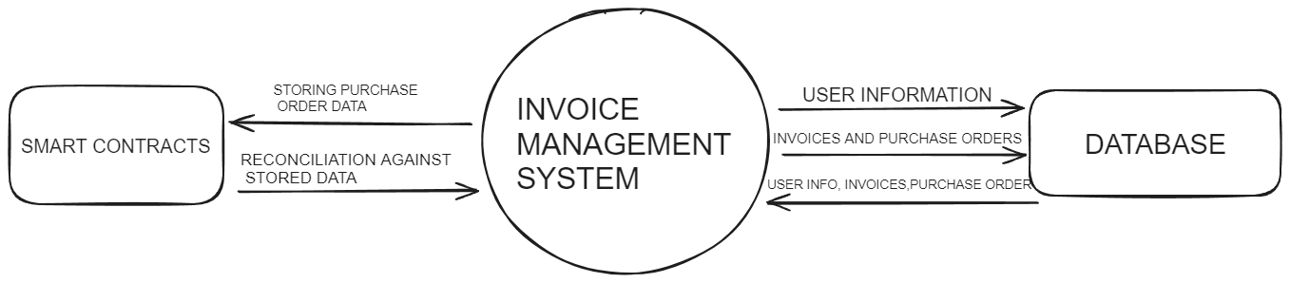

Program Flow Diagram

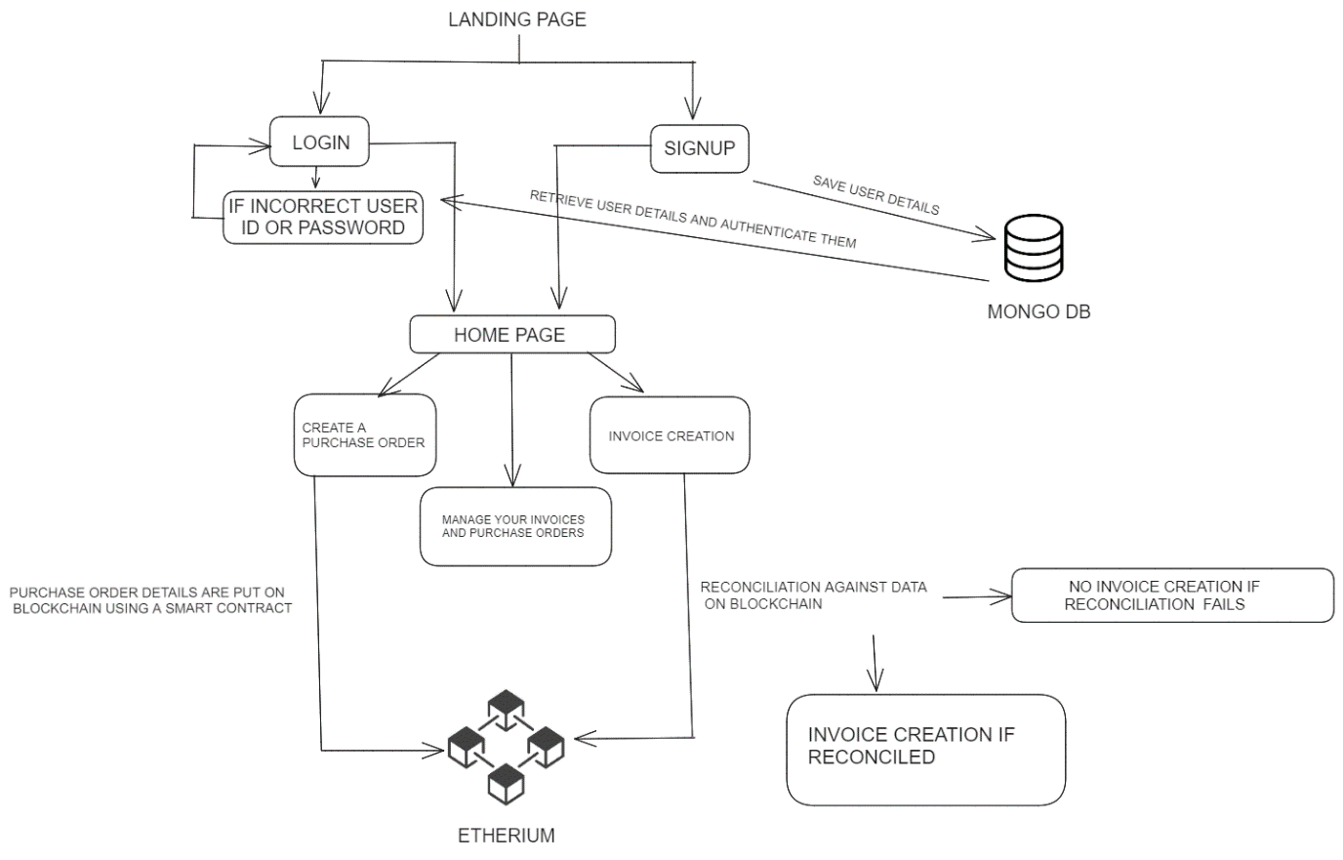

Data Flow Diagram